**B.R.A.C.T’S**

**Vishwakarma Institute Of Information Technology, Pune**

**Report on: 7 Days of Code**

**Organized by**: Computer Society of India, VIIT Pune Student Branch 2021-2022.

**Date**: 24th – 31st January, 2022

Platform: Hacker rank

**Intercollege Coding Competition**

7 days of Code is an intercollege coding competition organized by Computer Society of India, VIIT. The contest was scheduled from 24th – 31st January, 2022. The seven-day long competition was perfectly tailored to suit the expertise and experience of our fellow colleagues. The **40+ hours extension event** offers you an excellent opportunity to compete with your peers, brush up your skills, and learn lots of coding concepts. The competition offered a comprehensive overview of the type of questions that students are potentially going to encounter in interviews in the future as well.

7 days of code had in total 23 questions spread over a span of 7 days. Participants received six questions each on Day 1, Day 3 and Day 5. All the questions that were included in the contest were carefully drafted by team CSI. Every question was set to moderate difficulty so that participants gain confidence and put in sincere efforts to rank higher. Each question of the contest carried 100 marks. Furthermore, on the 7th Day, participants were provided with a set of 5 bonus questions, that would not affect their rank for the overall submission. To conclude the competition, CSI also provided the correct answers to all the questions that were put in the contest.

During the contest, all the submissions were monitored and any of the malpractices were identified. The participants were given accurate guidance about the conduction of the event and fair participation was monitored. CSI was able to successfully conclude the competition with a positive response from the students. Top-3, Top-10, and participation certificates were awarded to the contestants who had at least solved one question during the competition.

An image of a few questions and HackerRank interface in the live contest

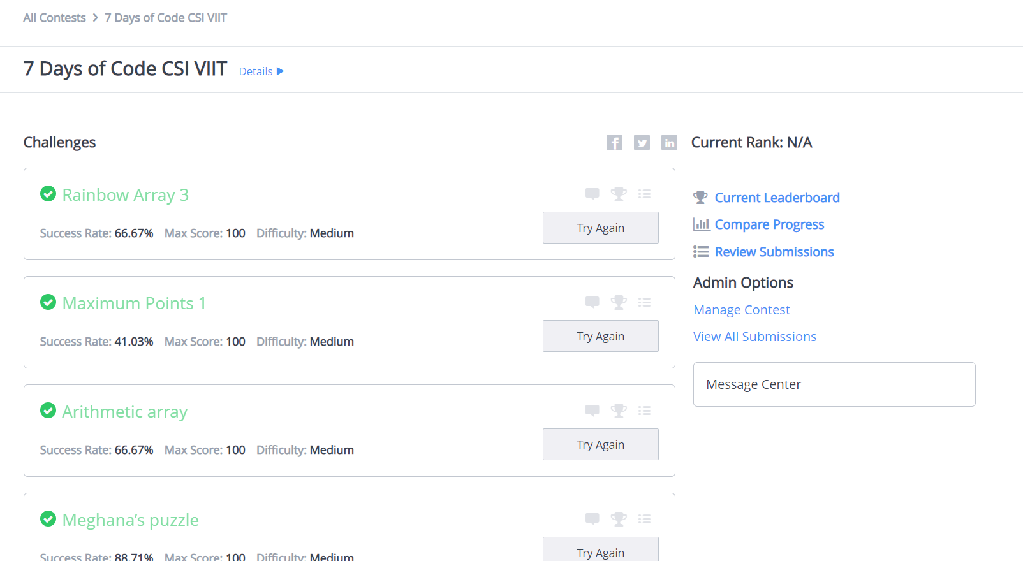

An image of Statistics of the contest including the Signup Count, Login Count, Conversion Rates and Number of Users who submitted code when the contest was Live

